**An overview and blueprint**

Below is a clear and structured abstract for your Pilates and diet website idea, followed by a breakdown of sections, elements, and a basic blueprint outlining the number of webpages and their contents.

**Abstract**

The proposed website is a comprehensive platform designed to promote health and wellness through Pilates workouts and personalized diet planning. It aims to engage users with a variety of Pilates exercises, structured fitness challenges, and tools to create tailored diet plans. The website is divided into three core sections: Pilates Workouts, Fitness Challenges, and Diet Planning, with an additional User Profile section for tracking progress. The Pilates Workouts section offers a library of exercises with recommendations based on user goals. The Fitness Challenges section provides 15-day and 30-day programs with progressively increasing difficulty, incorporating a gamified points system to boost motivation and cheerfulness. The Diet Planning section empowers users to calculate calories burned and consumed, and design custom diet plans factoring in age, weight, height, food preferences, and allergies. The User Profile section allows users to monitor their workout consistency, challenge progress, and dietary adherence. This interactive and user-centric platform seeks to inspire and support individuals in achieving their fitness and nutrition goals.

**Sections and Elements**

**1. Pilates Workouts Section**

* **Purpose**: Provide users with a variety of Pilates workouts and personalized recommendations.
* **Elements**:
  + Library of Pilates exercises (e.g., beginner, intermediate, advanced levels).
  + Video tutorials or animated demonstrations for each workout.
  + Search and filter options (e.g., by difficulty, duration, or focus area like core, flexibility).
  + Recommendation engine suggesting workouts based on user goals (e.g., weight loss, strength).
  + Brief descriptions of benefits for each workout.

**2. Fitness Challenges Section**

* **Purpose**: Offer structured 15-day and 30-day challenges to keep users motivated with increasing difficulty and rewards.
* **Elements**:
  + Challenge selection (e.g., "15-Day Core Starter" or "30-Day Full Body Transformation").
  + Daily workout plans with video links or instructions.
  + Progressive difficulty (e.g., Day 1: 10-min workout, Day 30: 45-min workout).
  + Points system (e.g., 10 points for completing a workout, bonus points for streaks).
  + Motivational messages or badges (e.g., “Consistency Champ” after 5 days).
  + Progress tracker (e.g., percentage of challenge completed).

**3. Diet Planning Section**

* **Purpose**: Enable users to calculate calories, track food intake, and create personalized diet plans.
* **Elements**:
  + Calorie calculator for workouts (based on workout duration and intensity).
  + Food database with calorie counts for common items.
  + Manual food entry option for custom meals.
  + Diet plan generator based on user inputs (age, weight, height, preferences, allergies).
  + Daily calorie intake vs. burned summary.
  + Tips or recipes aligned with user preferences and goals.

**4. User Profile Section**

* **Purpose**: Allow users to track their progress, consistency, and overall journey.
* **Elements**:
  + Dashboard with workout history (e.g., total minutes exercised, challenges completed).
  + Points tally and badges earned from challenges.
  + Diet log (e.g., weekly calorie intake vs. burned).
  + Graphs or charts showing progress (e.g., consistency streaks, weight changes if tracked).
  + Editable user details (e.g., age, weight, height, preferences).

**Website Blueprint: Number of Webpages and Content**

The website will consist of **7 main webpages**, each serving a distinct purpose while integrating the sections described above. Below is the basic structure:

**1. Home Page**

* **Content**:
  + Welcome message and brief overview of the website (Pilates, challenges, diet).
  + Call-to-action buttons (e.g., “Explore Workouts,” “Start a Challenge,” “Plan Your Diet”).
  + Highlights of features (e.g., points system, personalization).
  + Testimonials or success stories (optional).

**2. Pilates Workouts Page**

* **Content**:
  + Searchable workout library with filters.
  + Video or animation embeds for each exercise.
  + Recommended workouts section (personalized if user is logged in).
  + Links to related challenges.

**3. Fitness Challenges Page**

* **Content**:
  + List of available challenges (15-day, 30-day) with descriptions.
  + “Start Challenge” button leading to daily workout plans.
  + Points leaderboard or personal points tracker.
  + Motivational pop-ups or progress bars.

**4. Diet Planning Page**

* **Content**:
  + Calorie calculator tool for workouts.
  + Food logging interface with search or manual entry.
  + Diet plan generator form (inputs: age, weight, height, etc.).
  + Generated diet plan output with daily meal suggestions.

**5. User Profile Page**

* **Content**:
  + Dashboard with workout and diet stats.
  + Points and badges display.
  + Editable user information section.
  + Progress visuals (charts, graphs).

**6. About Page**

* **Content**:
  + Mission statement (e.g., promoting health through Pilates and diet).
  + Information about the team or creators (optional).
  + Contact details or support links.

**7. Login/Sign-Up Page**

* **Content**:
  + Registration form (e.g., email, password, basic details like age, weight).
  + Login form for returning users.
  + Password recovery option.

**Additional Notes**

* **Total Webpages**: 7 (Home, Pilates Workouts, Fitness Challenges, Diet Planning, User Profile, About, Login/Sign-Up).
* **Navigation**: Include a consistent header or sidebar menu linking to all main pages.
* **Interactivity**: Ensure pages like Diet Planning and User Profile are dynamic, updating based on user input and activity.
* **Design**: Use a cheerful, motivating aesthetic (bright colors, encouraging language) to align with the goal of keeping users engaged.

This blueprint provides a solid foundation for your website. Let me know if you'd like to refine any section or add more features

**Where can we integrate AI?**

Your Pilates and diet website offers several opportunities to integrate AI technologies to enhance functionality, personalization, and user experience. Below, I’ll outline where AI can be applied within each section of your website and suggest specific use cases.

**1. Pilates Workouts Section**

* **AI Opportunities**:
  + **Personalized Workout Recommendations**: Use AI to analyze user data (e.g., fitness level, goals, past workout history) and suggest tailored Pilates exercises. Machine learning models can predict which workouts suit a user based on patterns in their preferences or progress.
  + **Pose Detection and Feedback**: Integrate computer vision AI to analyze user-uploaded videos or live webcam feeds (if feasible) to provide real-time feedback on Pilates form and posture (e.g., “Adjust your back alignment”).
  + **Content Generation**: AI could generate workout descriptions or variations dynamically to keep the library fresh and engaging.
* **Why It Works**: AI enhances personalization and interactivity, making workouts feel bespoke and supportive, which aligns with user motivation.

**2. Fitness Challenges Section**

* **AI Opportunities**:
  + **Adaptive Challenge Difficulty**: Use AI to adjust the difficulty of daily workouts in the 15-day or 30-day challenges based on user performance (e.g., if a user struggles, reduce intensity; if they excel, increase it).
  + **Motivational Messaging**: Implement a natural language processing (NLP) model to generate personalized, cheerful motivational messages or tips (e.g., “Great job on Day 5, Sarah! You’re halfway to earning the Endurance Star!”).
  + **Predictive Analytics**: AI can predict dropout risk based on user engagement (e.g., skipped days) and trigger interventions like bonus points or reminders to keep them on track.
* **Why It Works**: AI-driven adaptability and encouragement can boost retention and make the challenges feel dynamic and responsive to individual needs.

**3. Diet Planning Section**

* **AI Opportunities**:
  + **Diet Plan Generator**: Use machine learning to create optimized diet plans by analyzing user inputs (age, weight, height, food preferences, allergies, calorie goals) and cross-referencing them with nutritional databases. AI can suggest balanced meals that align with Pilates goals (e.g., muscle recovery, fat loss).
  + **Calorie Prediction**: Train an AI model to estimate calories burned during Pilates workouts more accurately by factoring in user-specific data (e.g., weight, workout intensity) rather than relying on generic formulas.
  + **Food Recognition**: Integrate image recognition AI to allow users to upload photos of meals, with the system identifying food items and estimating calorie counts automatically.
  + **Preference Learning**: AI can learn from user food logs over time to refine suggestions (e.g., noticing a preference for plant-based meals and prioritizing those).
* **Why It Works**: AI makes diet planning seamless, precise, and user-friendly, reducing manual effort and increasing adherence.

**4. User Profile Section**

* **AI Opportunities**:
  + **Progress Insights**: Use AI to analyze workout and diet data, then provide actionable insights (e.g., “You’re 20% more consistent this month—keep it up!” or “Adding protein could boost your recovery”).
  + **Goal Forecasting**: Predictive AI can estimate how long it might take a user to reach a goal (e.g., weight loss, completing a 30-day challenge) based on current trends.
  + **Behavioral Nudges**: NLP-powered AI could generate personalized notifications or emails to celebrate milestones or gently nudge users back into consistency (e.g., “You’re 3 days away from a new badge!”).
* **Why It Works**: AI turns raw data into meaningful feedback, keeping users engaged with their progress and motivated to continue.

**Summary of AI Integration Opportunities**

* **Pilates Workouts**: Recommendation engine, pose detection, content generation.
* **Fitness Challenges**: Adaptive difficulty, motivational messaging, dropout prediction.
* **Diet Planning**: Diet plan generator, calorie prediction, food recognition, preference learning.
* **User Profile**: Progress insights, goal forecasting, behavioral nudges.

**Where AI Adds the Most Value**

* **Personalization**: Across all sections, AI can tailor experiences to individual users, which is key to motivation and retention.
* **Automation**: Tasks like calorie counting, workout adjustments, and diet planning become faster and more accurate.
* **Engagement**: Features like real-time feedback, adaptive challenges, and motivational messages make the website feel interactive and supportive.

If you decide to implement AI, you could start with simpler applications (e.g., a recommendation system or diet generator using pre-trained models) and scale up to advanced features (e.g., pose detection or image recognition) as the website grows. Let me know if you’d like help prioritizing or exploring specific AI tools for development!

Other references (Links):

* **Diet and workout Recommendation System | Food Recommendation System | Langchain and Openai APIs -** [Link](https://youtu.be/RCl7wGoocnw?feature=shared)
* **Diet Recommendation System using Machine Learning | Food Recommendation System using Python -** [**Link**](https://youtu.be/p5kXfbEf550?feature=shared)
* **Figma to HTML and CSS export | Create a responsive website from Figma to code -** [**Link**](https://youtu.be/kxW62eMsw0k?feature=shared)

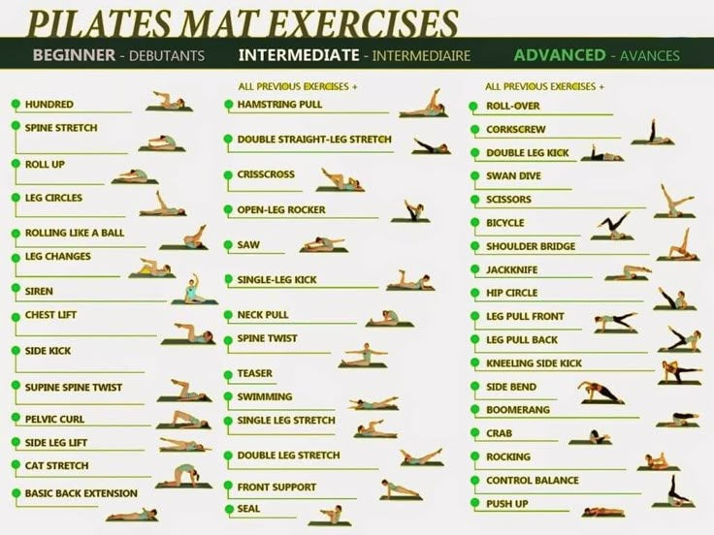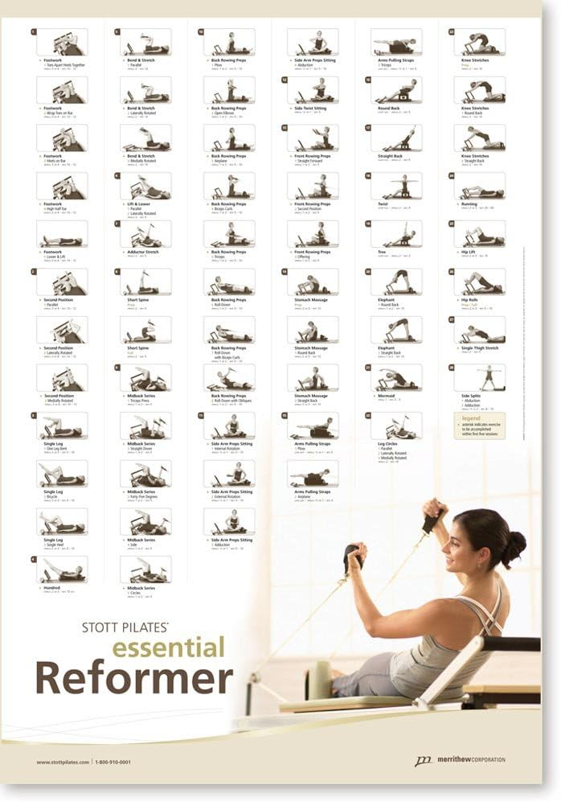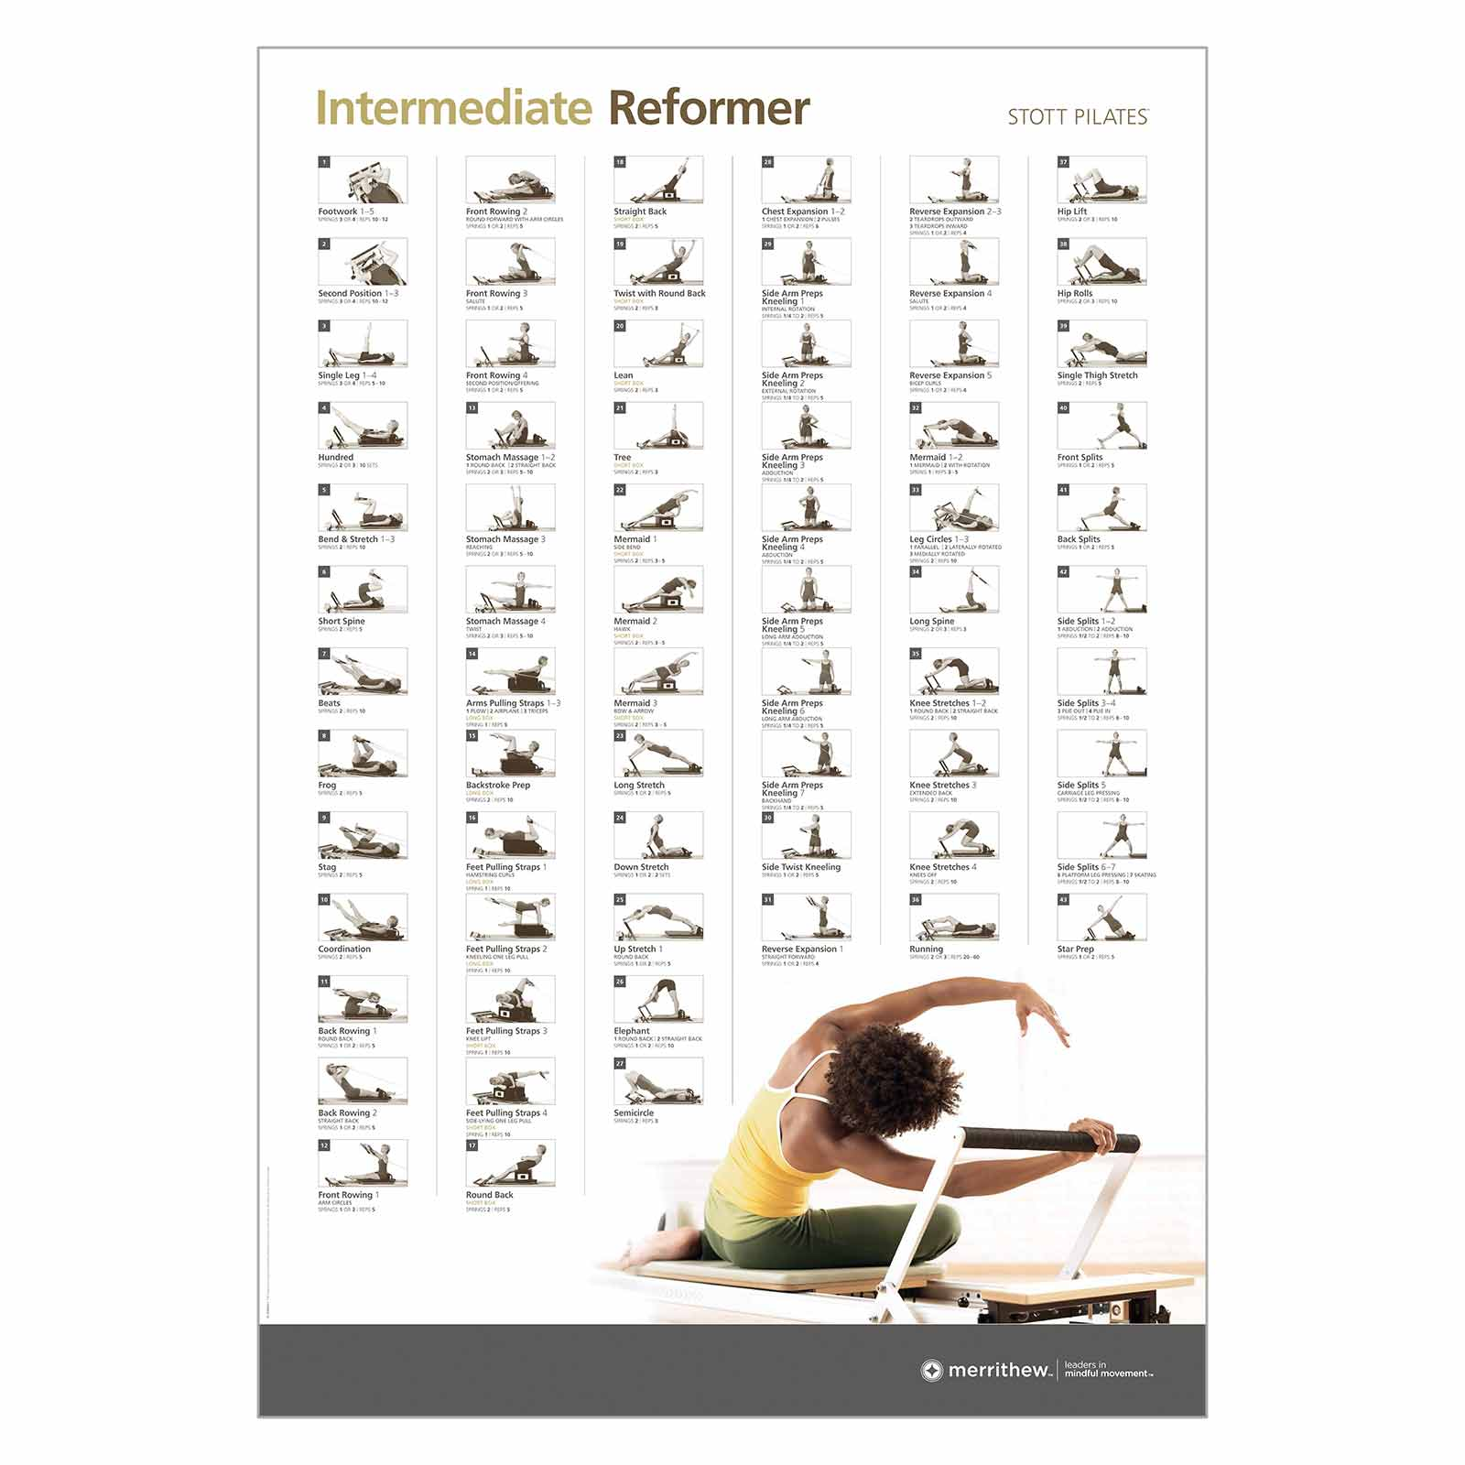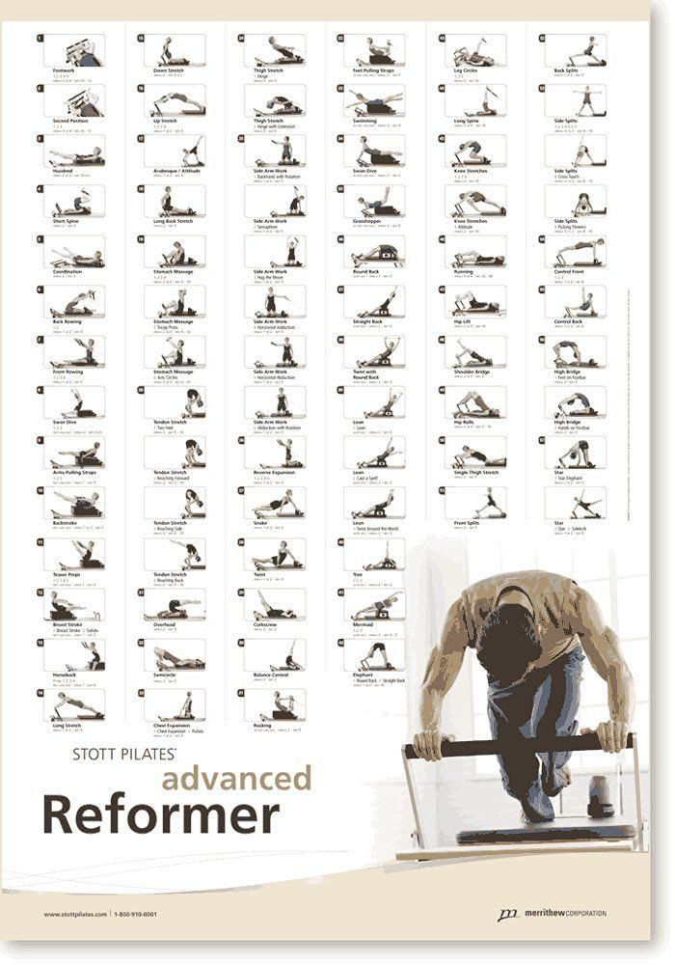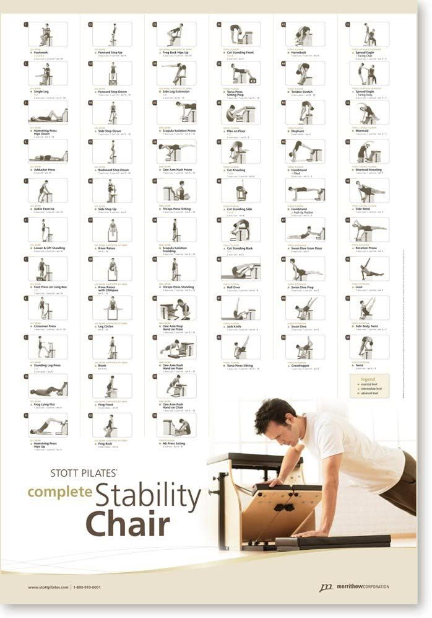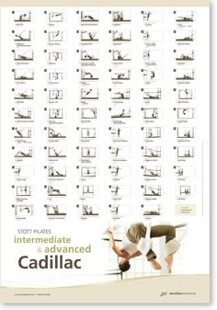**chrome-extension://efaidnbmnnnibpcajpcglclefindmkaj/https://btpilates.co.nz/pdf/pilates-**

[**pdf**](chrome-extension://efaidnbmnnnibpcajpcglclefindmkaj/https:/btpilates.co.nz/pdf/pilates-exercises/apilatesmatbasic.pdf)

